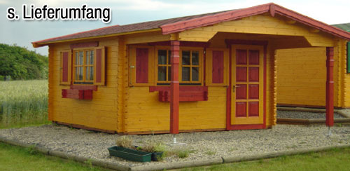 | 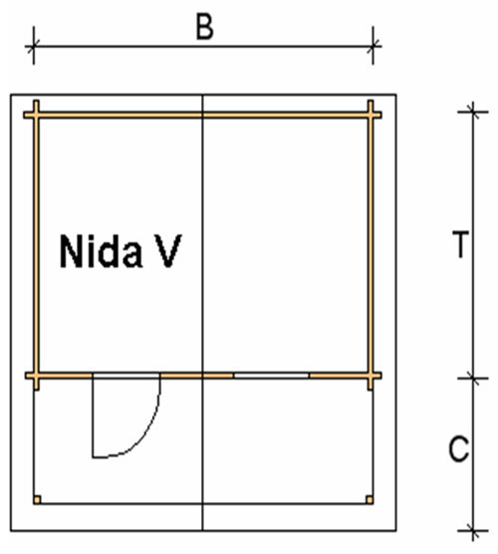
 | 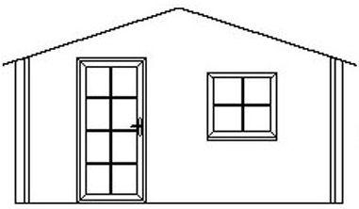

Nida-V Log Cabin
Roof projection: Front 2.00m
Back 0.20m
Side 0.30m

Consists of:
Walls: 45mm or (60mm glued) double tongue and groove logs from Northern Pine
Floor: 20mm tongue and groove floor boards on the impregnated base frame
Roof: 20mm tongue and groove roof boards on the roof beams
C = 2m overhang at the front
Door: 1 glued cartridge door 90/196 with seal
Windows: 1 double-glazed 80/94 tilt ‘n‘ turn unit1

Size (m) |  | Price (£) |  | Optional Extras
 |  |  |  | Roof Insulation (£) |  | Shingles (£)
B | T | 45 | 60 | 45 | 60 | Shingles (£)
3 | 3 | 2080 | - | 117 | - | 145
3 | 4 | 2465 | - | 140 | - | 194
4 | 3 | 2545 | - | 140 | - | 194
4 | 4 | 2912 | 3710 | 169 | 172 | 238
4 | 5 | 3529 | 4310 | 191 | 194 | 270
5 | 4 | 3620 | 4410 | 198 | 200 | 270
5 | 5 | 4202 | 4802 | 224 | 225 | 295

Optional Extras:

Single window £83
Double window 1200/940 £124
Single door £159
Double door 1700/1970 £267

